**Bresenham’s Line Generation**

The Bresenham’s algorithm is another incremental line drawing algorithm. The big advantage of this algorithm is that, it uses only integer calculations. Moving across the x axis in unit intervals and at each step choose between two different y coordinates.

For example, as shown in the following illustration, from position (2, 3) you need to choose between (3, 3) and (3, 4). You would like the point that is closer to the original line.

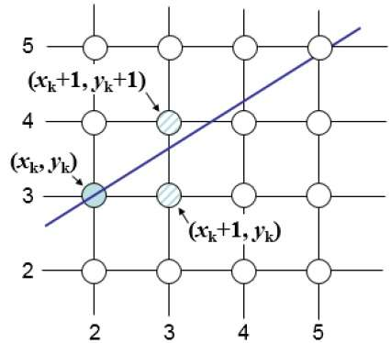

At sample position Xk+1 the vertical separations from the mathematical line are labeled as dupper and dlower.

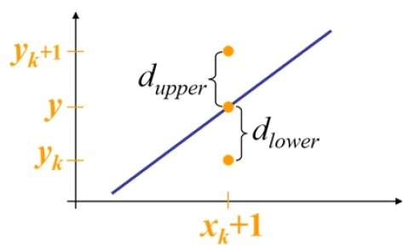

From the above illustration, the y coordinate on the mathematical line at **xk+1** is

***Y = m(Xk+1) + b***

So, ***dupper*** and ***dlower*** are given as follows :

***dlower = y−yk = m(Xk+1)+b−Yk***

***dupper = (yk+1)−y = Yk+1−m(Xk+1)−b***

You can use these to make a simple decision about which pixel is closer to the mathematical line. This simple decision is based on the difference between the two pixel positions.

***dlower−dupper=2m(xk+1)−2yk+2b−1***

Let us substitute m with dy/dx where dx and dy are the differences between the end-points and multiply both side with dx.

***dx(dlower−dupper)=dx(2dy/dx(xk+1)−2yk+2b−1)***

***=2dy.xk−2dx.yk+2dy+2dx(2b−1)***

***=2dy.xk−2dx.yk+C***

Where C represents all the constants in the equation, So a decision parameter Pk for the kth step along a line is given by

***pk=dx(dlower−dupper) = 2dy.xk−2dx.yk+C***

The sign of the decision parameter Pk is the same as that of dlower−dupper. If pk is negative, then choose the lower pixel, otherwise choose the upper pixel. Remember, the coordinate changes occur along the x axis in unit steps, so you can do everything with integer calculations. At step k+1, the decision parameter is given as

***pk+1=2dy.xk+1−2dx.yk+1+C***

Subtracting pkfrom this we get −

***pk+1 - pk=2dy(xk+1−xk)−2dx(yk+1−yk)***

But, Xk+1 is the same as xk + 1. So

***pk+1=pk+2dy−2dx(yk+1−yk)***

WhereYk+1–Ykis either 0 or 1 depending on the sign of Pk. The first decision parameter P0 is evaluated at (x0,y0) & it is given as

***p0=2dy−dx***

Using this decision parameter, it is decided what point to choose, when drawing using Bresenham’s.

**Bresenham’s Algorithm Steps.**

All the calculations in this algorithm are in integers which makes it better than the floating point line drawing algorithms like DDA.

1. **Step 1:**  Take the input of the two endpoints of the line that is to be drawn. Let the starting point be (x0, y0) and let the ending point be (xe,ye). Where y1 >= y0 and x1 > x0 to make the slope less than one.
2. **Step 2:** Plot the first point i.e. x0, y0.
3. **Step 3:** Calculate dx, dy, 2dx, 2dy, 2dy-2dx & P0 = 2dy-dx.
4. **Step 4:**  At each step of the x coordinate i.e. Xk, Yk is to be calculated based on the decision parameter. The calculations will be as follows:

* The decision parameter for the first step P0 is calculated using the formula 2dy –dx.
* 1.If Pk > 0, We plot (xk + 1, yk + 1) and Pk+1 will be calculated using Pk +2dy – 2dx. Which means that yk+1 – Yk will become 1.
* 2. If Pk < 0, We plot (xk + 1, yk) and Pk+1 will be calculated using the formula Pk +2dy. Which means that yk+1 – Yk will become 0.

1. **Step 5:** Repeat step 4 and plot the point at each step or iteration until the endpoint is reached.

**Example of the Line drawing Algorithm using Bresenham’s**

The example will plot a line from (20, 10) to (30, 18) using the Bresenham’s line drawing Algorithm. First plot the starting point coordinates x0, y0 which is (20, 10). For each step the value of x coordinate we will need to decide if we will increment the y coordinate or not.

The values that should be calculated beforehand to make the calculations easier are

1. **dy** = 18 – 10 =8
2. **dx** = 30 – 20 = 10
3. **2dy** = 2 x 8 = 16
4. **2dx** = 2 x 10 = 20
5. **2dy – 2dx** = 16 – 20 = -4
6. **2dy – dx** = **P0** = 16 – 10 = 6

At the 0th value the p0 is 6, the decision parameter P0 is positive therefor both x and the y coordinates will be incremented. So the point plotted will be (21, 11). In the 1th step the value of Pk  is calculated again. This time the decision parameter P1  is calculated using the formula **Pk + 2dy – 2dx = 6 + 2(8) – 2(10) = 2 (for +ive decision factor)**. Since the value of the decision parameter from the last step was positive the formula to calculate the decision parameter in this step will have the value of Yk+1 -Yk = 1. Which means that the formula will contain the **-2dx** part in it.In the 2th step the value of P2 will be calculated using the formula **Pk + 2dy – 2dx = 2 + 2(8) – 2(10) = -2.** Since the decision parameter in this step will be negative the x coordinate in the next step will be incremented but the y coordinate will remain the same. For the 3th step the decision parameter will be calculated using the formula **Pk + 2dy = -2 + 16 = 14(for –ive decision factor).**

|  |  |  |  |
| --- | --- | --- | --- |
| Sr no (k) | Xk | Yk | Pk |
| 0 | 20 | 10 | 6 |
| 1 | 21 | 11 | 2 |
| 2 | 22 | 12 | -2 |
| 3 | 23 | 12 | 14 |
| 4 | 24 | 13 | 10 |
| 5 | 25 | 14 | 6 |
| 6 | 26 | 15 | 2 |
| 7 | 27 | 16 | -2 |
| 8 | 28 | 16 | 14 |
| 9 | 29 | 17 | 10 |
| 10 | 30 | 18 |  |

Line from (2, 5) to (10, 8)

dy = 8 – 5 = 3

dx = 10 – 2 = 8

2dy = 6

2dx = 16

2dy - 2dx = -10

Po = 2dy – dx = -2

|  |  |  |  |
| --- | --- | --- | --- |
| K (STEP) | XK | yK | Pk |
| 0 | 2 | 5 | -2 (Pk + 2dy) 6 – 2 = 4 |
| 1 | 3 | 5 | 4 (Pk +2dy -2dx) = -6 |
| 2 | 4 | 6 | -6 (Pk + 2dy) = 0 |
| 3 | 5 | 6 | 0 (0 - 10) = -10 |
| 4 | 6 | 7 | -10 (-10 + 6) = -4 |
| 5 | 7 | 7 | -4 (-4 + 6) = 2 |
| 6 | 8 | 7 | 2 (2 - 10) = -8 |
| 7 | 9 | 8 | -8 |
| 8 | 10 | 8 |  |

For Slope > 1

Repeat X and will always add to y (Y never gets repeated).

Po = 2dx – dy

Pk+1 = Pk + 2dx – 2dy (+ive)

Pk+1 = Pk + 2dx (-ive)

Assignment: Solve one example for slope greater than 1.

**Line from A(3, 5) to B(13, 9) using Bresenham’s**

Slope = m = (y2 – y1)/(x2 – x1) = dy/dx = (4)/(10) = 0.4

1. dy = 4
2. dx = 10
3. 2dy = 8
4. 2dx = 20
5. 2dy – 2dx = -12
6. P0 = 2dy -dx = -2

|  |  |  |  |  |
| --- | --- | --- | --- | --- |
| k | Xk | Yk | Pk | Pk+1 |
| 0 | 3 | 5 | -2 | Pk + 2dy = -2 + 8 = 6 |
| 1 | 4 | 5 | 6 | Pk + 2dy – 2dx = 6 – 12 = -6 |
| 2 | 5 | 6 | -6 | Pk + 2dy = -6 + 8 = 2 |
| 3 | 6 | 6 | 2 | Pk + 2dy – 2dx = 2 – 12 = -10 |
| 4 | 7 | 7 | -10 | Pk + 2dy = -10 + 8 = -2 |
| 5 | 8 | 7 | -2 | Pk + 2dy = -2 + 8 = 6 |
| 6 | 9 | 7 | 6 | Pk + 2dy – 2dx = 6 – 12 = -6 |
| 7 | 10 | 8 | -6 | Pk + 2dy = -6 + 8 = 2 |
| 8 | 11 | 8 | 2 | Pk + 2dy – 2dx = 2 – 12 = -10 |
| 9 | 12 | 9 | -10 |  |
| 10 | 13 | 9 |  |  |